**Detecting Building Defects Using VGG16 & IBM Watson**

**1. INTRODUCTION**

# 1.1 OVERVIEW

Detection of defects including cracks and flakes on the wall surfaces in high-rise buildings is a crucial task of buildings’ maintenance. If left undetected and untreated, these defects can significantly affect the structural integrity and the aesthetic aspect of buildings, timely and cost-effective methods of building condition surveys are of practicing need for the building owners and maintenance agencies to replace the time- and labor-consuming approach of the manual survey.

Clients are increasingly looking for fast and effective means to quickly and frequently survey and communicate the condition of their buildings so that essential repairs and maintenance work can be done in a proactive and timely manner before it becomes too dangerous and expensive. Traditional methods for this type of work commonly comprise of engaging building surveyors to undertake a condition assessment which involves a lengthy site inspection to produce a systematic recording of the physical condition of the building elements, including cost estimates of immediate and projected long-term costs of renewal, repair and maintenance of the building.

In this project detecting building defects such as cracks , flakes and roof defects, We are using CNN pretrained model VGG16 to analyze the type of building defect on the given parameters. The objective of the project is to build an application to detect the type of building defect. The model uses an integrated webcam to capture the video frame and the video frame is compared with the pre-trained model and the type of building defect is identified and showcased on the OpenCV window and emergency pull is initiated.

# 1.2 PURPOSE

By the end of this project, we will understand the fundamental concepts and Transfer Learning techniques. Also gain a broad understanding of image data. It will know how to pre-process and resize the data using different data preprocessing techniques. And also, how to build a web application using the Flask framework. Traditional methods for this type of work commonly comprise of engaging building surveyors to undertake a condition assessment which involves a lengthy site inspection to produce a systematic recording of the physical condition of the building elements, including cost estimates of immediate and projected long-term costs of renewal, repair and maintenance of the building. Current asset condition assessment procedures are extensively time consuming, laborious, and expensive and pose health and safety threats to surveyors, particularly at height and roof levels which are difficult to access.

# LITERATURE SURVEY

## 1.2 EXISTING PROBLEM

Image analysis techniques for detecting defects have been proposed as an alternative to the manual onsite inspection methods. Whilst the latter is time-consuming and not suitable for quantitative analysis, image analysis-based detection techniques, on the other hand, can be quite challenging and fully dependent on the quality of images taken under different real-world situations (e.g., light, shadow, noise, etc.). In recent years, researchers have experimented with the application of a number of soft computing and machine learning-based detection techniques as an attempt to increase the level of automation of asset condition inspection. The literature also includes a number of papers devoted to the detection of defects in infrastructural assets such as cracks in road surfaces, bridges, dams, and sewerage pipelines

Clients with multiple assets are increasingly requiring intimate knowledge of the condition of each of their operational assets to enable them to effectively manage their portfolio and improve business performance. This is being driven by the increasing adverse effects of climate change, demanding legal and regulatory requirements for sustainability, safety and well-being, and increasing competitiveness. Clients are looking for fast and effective means to quickly and frequently survey and communicate the condition of their buildings so that essential maintenance and repairs can be done in a proactive and timely manner before it becomes too dangerous and expensive . Traditional methods for this type of work commonly comprise of engaging building surveyors to undertake a condition assessment which involves a lengthy site inspection resulting in a systematic recording of the physical conditions of the building elements with the use of photographs, note taking, drawings and information provided by the client . The data collected are then analysed to produce a report that includes a summary of the condition of the building and its elements . This is also used to produce estimates of immediate and projected longterm costs of renewal, repair and maintenance of the building. Current asset condition assessment procedures are extensively time consuming, laborious and expensive, and pose health and safety threats to surveyors, particularly at height and roof levels which are difficult to access for inspection .

## 1.3 PROPOSED SOLUTION

In this project detecting building defects such as cracks , flakes and roof defects, We are using CNN pretrained model VGG16 to analyze the type of building defect on the given parameters. The objective of the project is to build an application to detect the type of building defect. The model uses an integrated webcam to capture the video frame and the video frame is compared with the Pre-trained model and the type of building defect is identified and showcased on the OpenCV window and emergency pull is initiated.

# THEORITICAL ANALYSIS

## BLOCK DIAGRAM

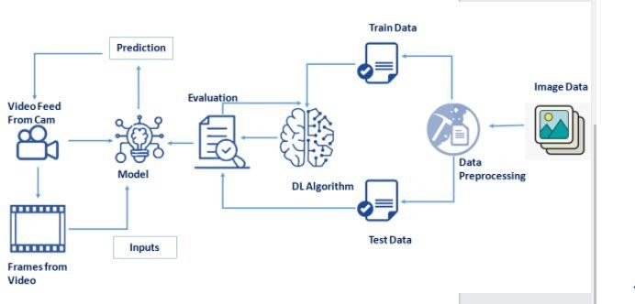

## HARDWARE/SOFTWARE DESIGNING

**SOFTWARE DESIGNING:**

1. Jupyter Notebook Environment
2. Spyder
3. Deep Learning Algorithms
4. Python ( numpy, scikitlearn ,opencv seaborn, sklearn)
5. HTML
6. Flask

We developed this Detecting building defects status prediction by using the Python language which is a interpreted and high level programming language and using the Deep Learning algorithms. for coding we used the Jupyter Notebook environment of the Anaconda distributions and the Spyder, it is an integrated scientific programming in the python language. For creating an user interface for the detection we used the Flask. It is a micro web framework written in Python. It is classified as a micro frame work because it does not require particular tools or libraries. It has no database abstraction layer, form validation, or any other components where pre-existing third-party libraries provide common functions, and a scripting language to create a webpage is HTML by creating the templates to use in the functions of the Flask and HTML.

**HARDWARE REQUIRMENTS**

* Processor : Intel Core i3
* Hard Disk Space : Min 100 GB
* Ram : 4 GB
* Display : 14.1 “Color Monitor(LCD, CRT or LED)

# EXPERIMENTAL INVESTIGATIONS

It is important to note that the size of the model was also considered as an important factor along with performance to ensure the viability of the models lower-cost smart phones.

Comparable performance was achieved to confirm that the proposed model is not localized or biased to the dataset on which it was trained.

By the end of this project I :

* Know fundamental concepts and techniques of the Artificial Neural Network and Convolution Neural Networks
* Gained a broad understanding of image data.
* Worked with Sequential type of modeling
* Worked with Keras capabilities
* Worked with image processing techniques
* know how to build a web application using the Flask framework.

# FLOWCHART

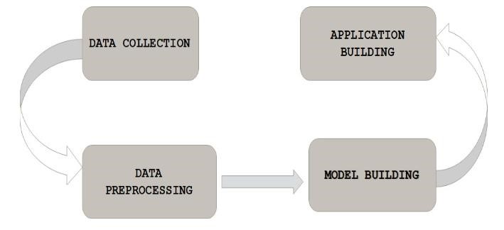

# RESULT

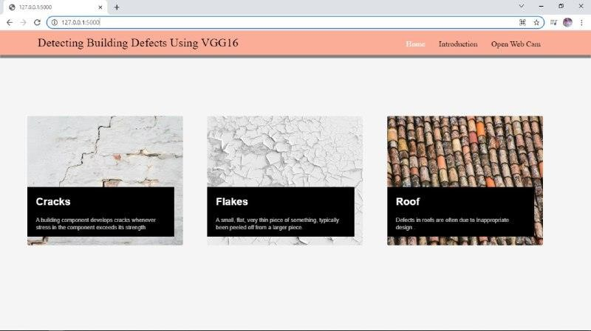

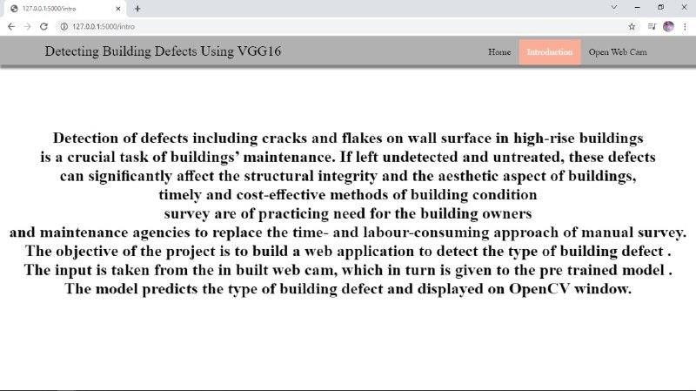

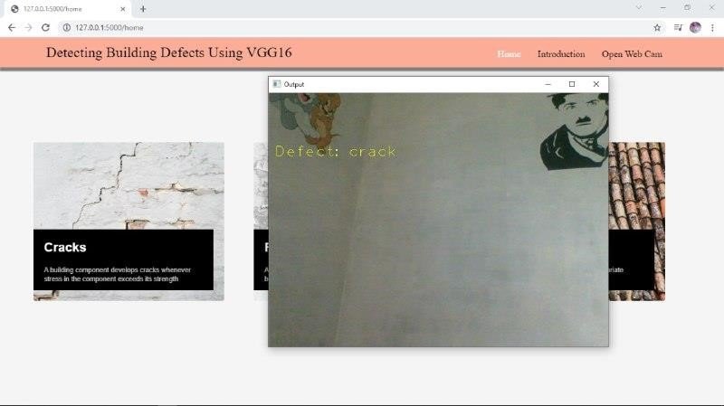

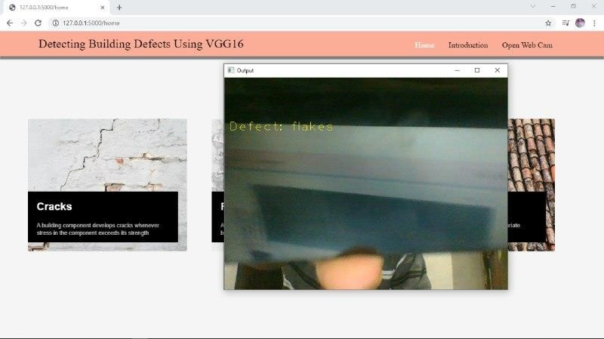

# ADVANTAGES

* Portability
* Anyone Can Apply

# APPLICATIONS

* Deployment for the project can be in the form of an interactive Web Based Platform, where users can enter their details as per the model requirement and get the predictions as a result.
* A web application can be used to launch the model for direct customer use.
* The user interacts with the UI (User Interface) to open the integrated webcam.

* The video frames are captured and analyzed by the model which is integrated with flask application.

* Once model analyses the video frames, the prediction is showcased on the UI and OpenCV window

# CONCLUSION

In this project detecting building defects such as cracks, flakes and roof defects, we are using CNN pre-trained model VGG16 to analyze the type of building defect on the given parameters. The objective of the project is to build an application to detect the type of building defect. The model uses an integrated webcam to capture the video frame and the video frame is compared with the pretrained model and the type of building defect is identified and showcased on the OpenCV window and emergency pull is initiated.

# FUTURE SCOPE

A rigorous analysis of other deep learning algorithms other than these can also be done in future to investigate the power of machine learning algorithms for detecting building defects. In further study, we will try to conduct experiments on larger data sets or try to tune the model so as to achieve the state -ofart performance of the model and a great UI support system making it complete web application model.

# APPENDIX

**Python(Source Code)**

